Relias Training Guide

How to register:

- Go to http://magellan.training.reliaslearning.com
- Click “Need a user account? Register Now.”
- In professional information section,
  - Organization: Leave Blank
  - Job Title: Magellan Provider
  - Departments: Magellan Provider
  - Profession: Psychology
  - Primary License State: Pennsylvania
- Follow accompanied Relias tutorial

Step 1:
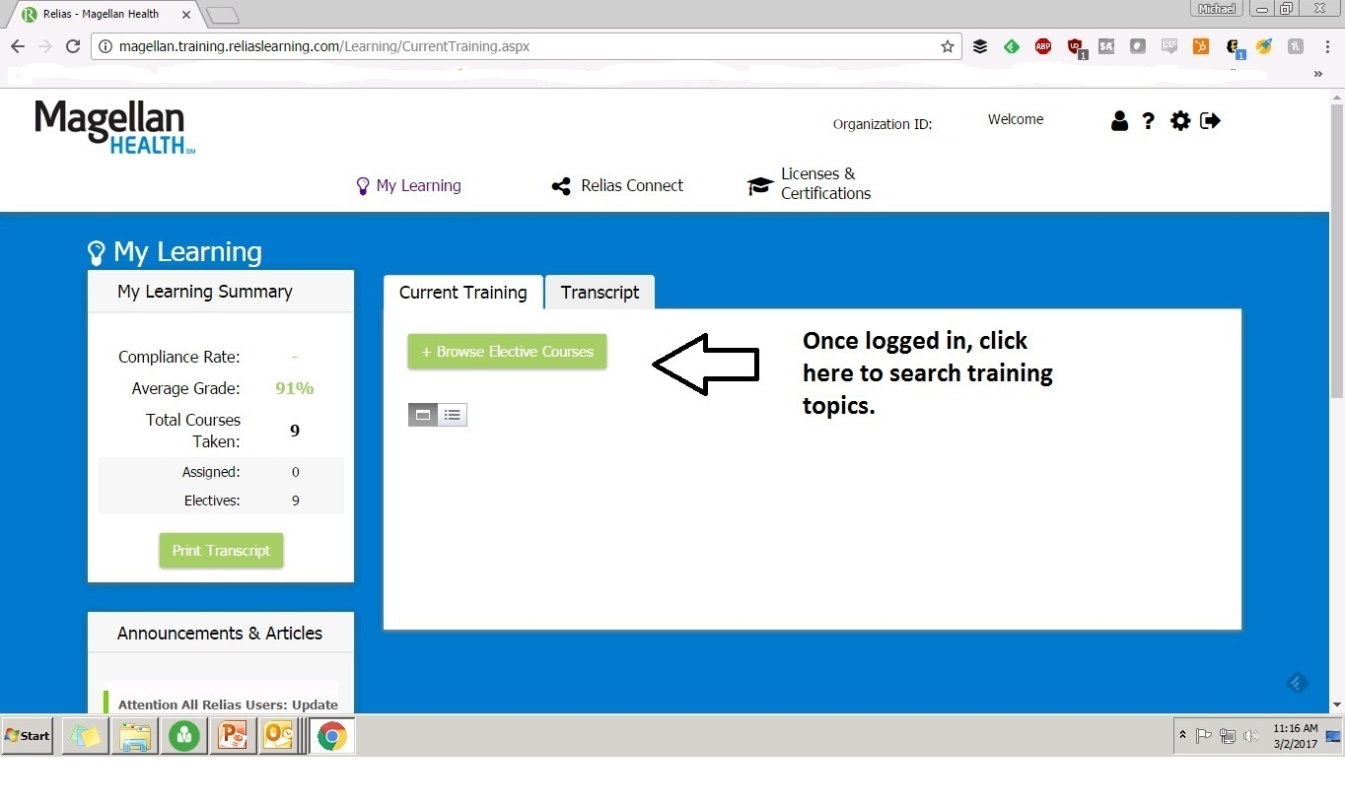
Step 2:
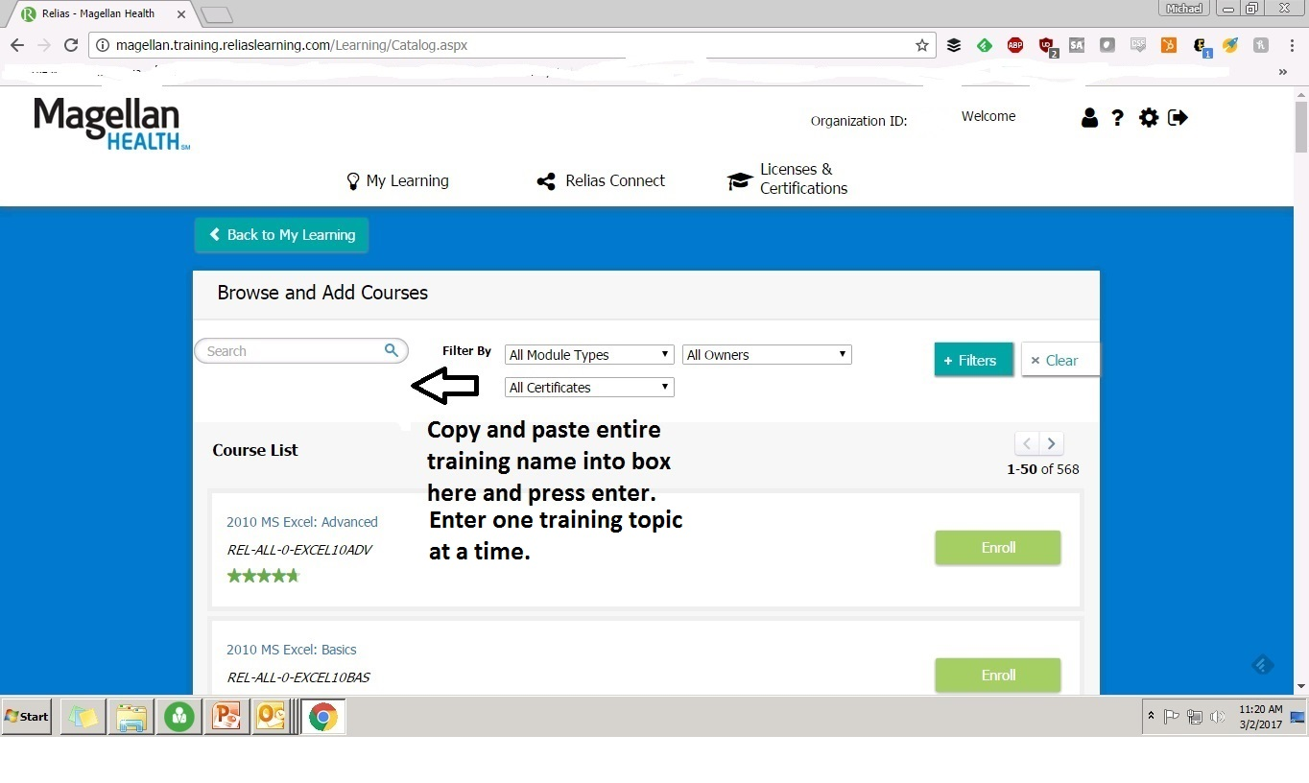
Step 3:
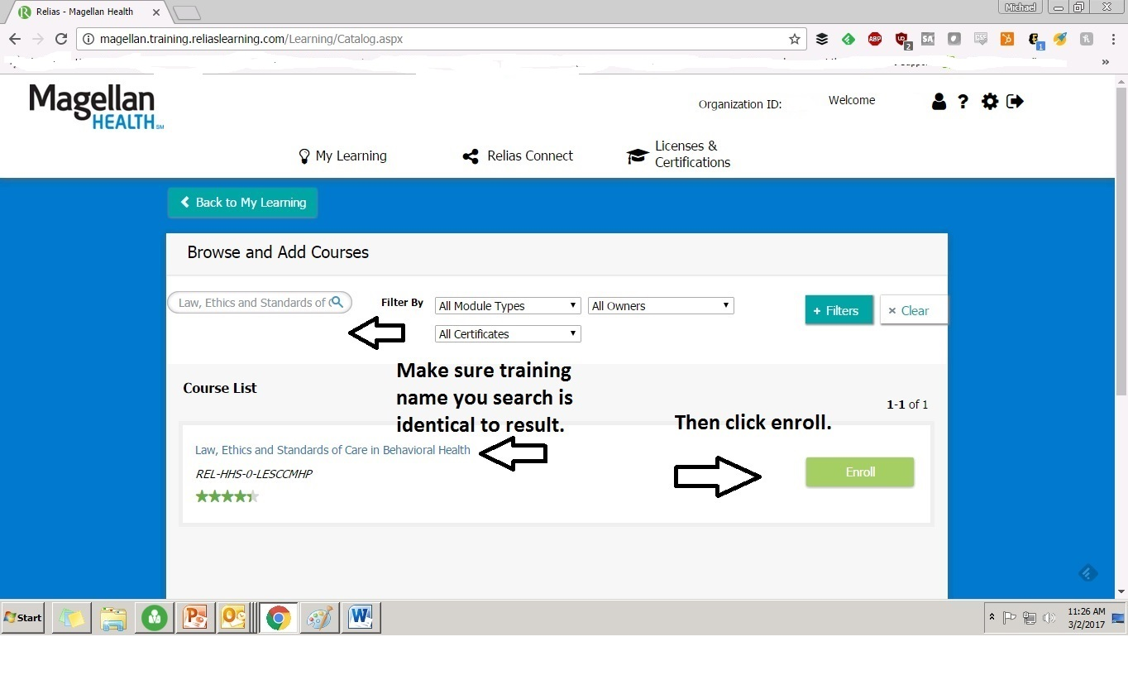
Step 4:
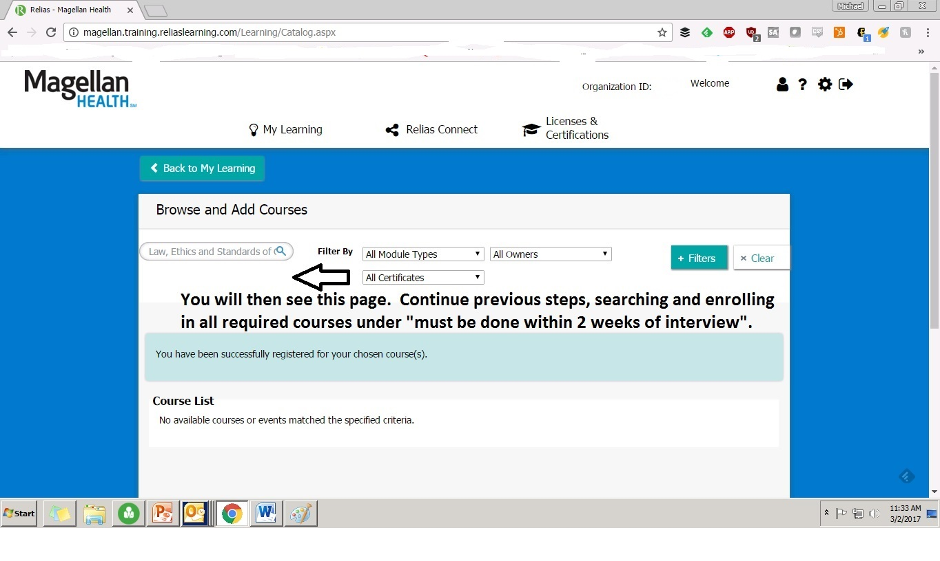
Step 5:
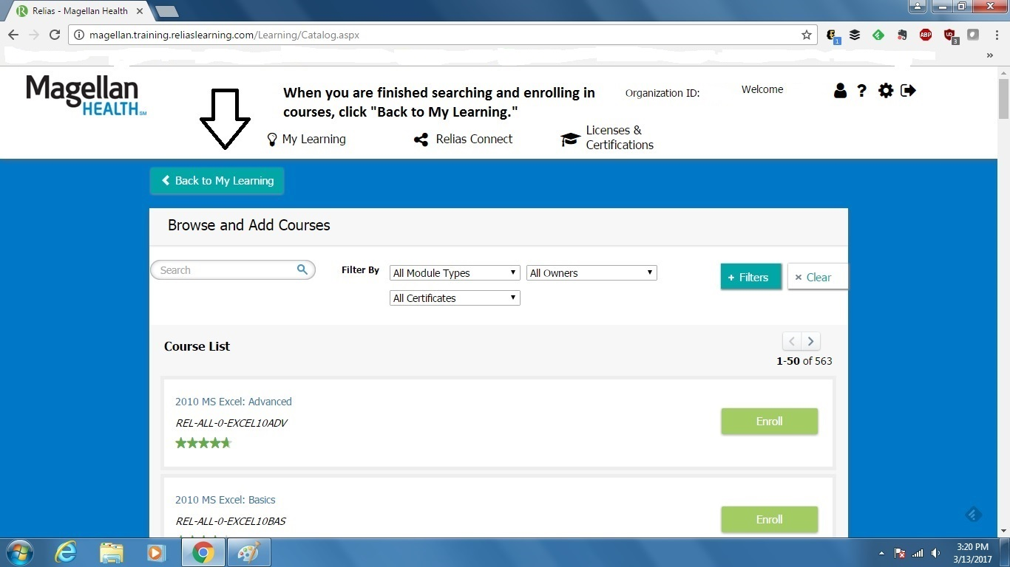

Step 6:
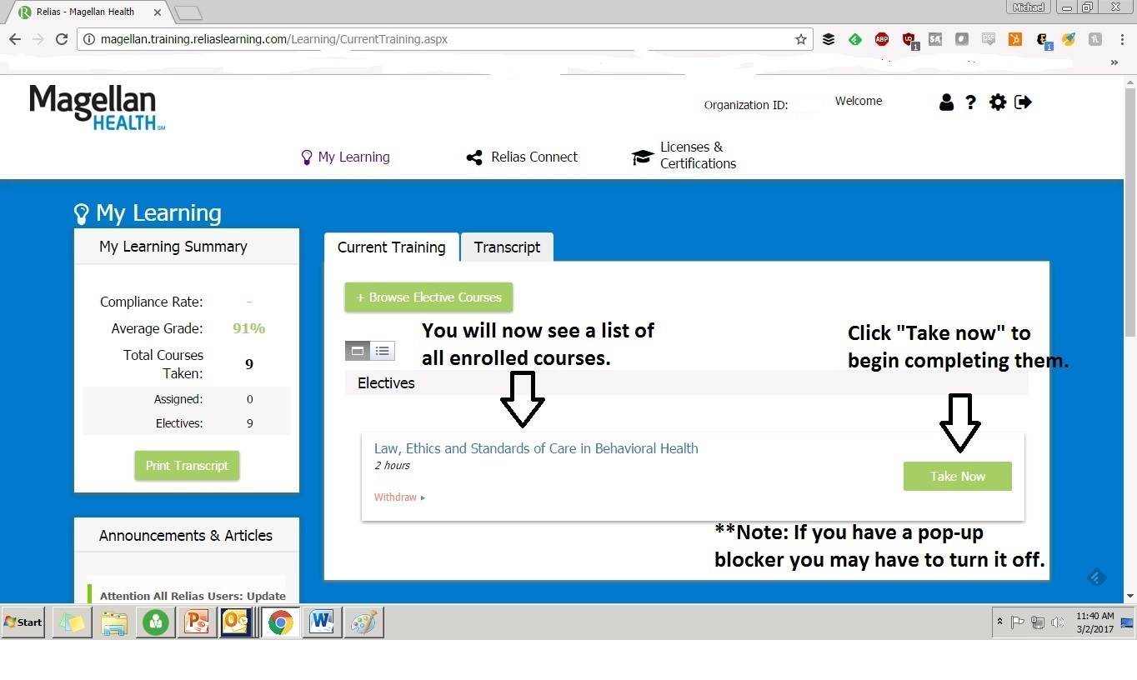
Step 7:
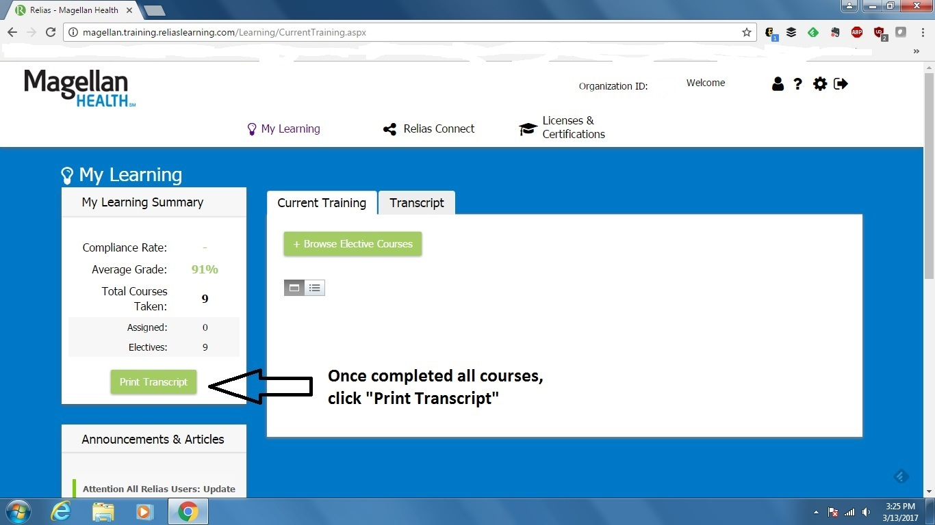

Step 8:
